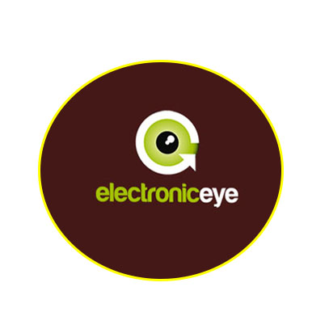

***CHITTAGONG POLYTECHNIC INSTITUTE***

Nasirabad, Chittagong

***Department****:* ***Electronics Technology***

***PROJECT NAME: Electrionic Eye Controller***

***SUBJECT NAME: Electronic Servicing-1***

**Subject Code**: ***66844***

***Group Name:***

***Fellowship :***

***1. Saiful Islam (Promoter) (384152)***

***2. Aminul Islam (384142)***

***3. MD. Wahid***

***4.***

***Submitted To: MD Rezaul Karim***

***Senior Instructor, Electronics.***